

PARSHVANATH CHARITABLE TRUST'S
- P. Shah Institute of Technology
Thane, 400615

Academic Year: 2023 - 2024
Department of Computer Engineering

CSL605 SKILL BASED LAB COURSE: CLOUD COMPUTING

Mini Project Report

- Title of Project :Book Manager

- Year and Semester : T.E. (Sem VI)

- Group Members Name and Roll No. :
            - Kumar Madagunaki (72)
            - Affan Khan (63)
            - Rahil Khan (64)

Table of Contents
Sr. No. | Topic | Page No.
1. | Problem Definition | 1
2. | Introduction | 2
3. | Description (Include the cloud services used in the project, methodologies used and software requirements) | 3
4. | Implementation details with screen-shots (stepwise) | 4
5. | Learning Outcome | 8

Problem Definition:
In today's digital age, the abundance of available books presents a challenge for individuals seeking to manage their personal book collections effectively. With the rise of online bookstores and digital libraries, users are faced with the daunting task of organizing, tracking, and updating the details of their ever-expanding literary treasures. Existing solutions for book management often lack the flexibility, customization, and user-friendliness required to meet the diverse needs and preferences of users. Traditional methods, such as maintaining manual lists or using spreadsheets, prove to be cumbersome and time-consuming, particularly as book collections grow in size and complexity. Moreover, the process of adding, editing, and deleting book details may be disjointed or unintuitive, requiring users to navigate multiple platforms or interfaces to perform basic tasks. This fragmentation not only leads to inefficiencies but also increases the likelihood of data inconsistencies and user frustration. To address these challenges, there arises a pressing need for a comprehensive and user-friendly book management solution. Such a solution should empower individuals to organize, update, and maintain their book collections effortlessly, providing a centralized platform that streamlines the management process and enhances the overall reading experience. The development of a book manager project aims to bridge this gap by offering users a convenient and intuitive tool for managing their book collections effectively. Through thoughtful design, robust functionality, and user-centric features, the book manager project seeks to simplify the process of book management and empower users to take control of their literary journeys with ease and efficiency.

Introduction:
In today's interconnected world, where information flows freely across digital channels and boundaries, the sheer abundance of literature available to individuals is both a blessing and a challenge. As readers immerse themselves in a diverse array of books spanning genres, formats, and languages, the task of managing personal book collections has become increasingly complex and demanding. The rise of online bookstores, digital libraries, and e-reader devices has democratized access to literature, offering readers unprecedented convenience and choice. However, with this proliferation of content comes the need for effective organization, cataloging, and management—a task that traditional methods struggle to accommodate. For many avid readers, the process of managing their book collections often begins with handwritten lists or makeshift spreadsheets, hastily compiled in an attempt to keep track of titles, authors, and reading progress. Yet, as their collections grow in size and diversity, these rudimentary tools prove inadequate, leading to frustration, inefficiency, and disorganization. Moreover, the fragmented nature of existing solutions exacerbates the challenge, forcing users to juggle multiple platforms, applications, and interfaces to perform basic management tasks. This disjointed experience not only hampers productivity but also detracts from the joy and satisfaction of owning and engaging with one's personal library. In response to these challenges, there arises a compelling opportunity to develop a comprehensive and user-centric book management solution—a digital ecosystem that seamlessly integrates with the modern reader's lifestyle and preferences. Such a solution would provide a unified platform where users can effortlessly organize, discover, and engage with their literary collections, fostering a deeper connection with their reading journey. The development of a book manager project represents a bold step towards realizing this vision, offering readers a sophisticated yet intuitive tool for managing and exploring their personal book collections. By harnessing the power of technology and design, the project aims to revolutionize the way individuals interact with their books, empowering them to curate, discover, and share their favorite titles with ease and efficiency. Through innovative features, seamless integration, and a relentless commitment to user experience, the book manager project seeks to redefine the paradigm of book management in the digital age. By providing readers with a versatile and intuitive platform to organize, explore, and engage with their literary passions, the project aims to enhance the joy and fulfillment of owning and experiencing books in all their myriad forms.

Description:

AWS Services:

The Book Manager web application will be built using a range of AWS services, each fulfilling a specific role in ensuring the scalability, reliability, and security of the application architecture:

1.Elastic Beanstalk: AWS Elastic Beanstalk streamlines our deployment process by automating provisioning, load balancing, auto-scaling, and infrastructure monitoring. This allows us to focus on developing and deploying our application code without the hassle of managing infrastructure complexities. By accelerating our time-to-market and enabling seamless scalability, Elastic Beanstalk ensures our application can efficiently handle varying user traffic levels.

2.RDS (Relational Database Service): RDS will be utilized to host the relational database that stores user account information, task lists, and associated metadata. By leveraging RDS, we can benefit from managed database services, including automated backups, security patching, and high availability configurations. This ensures that our application's data remains secure, highly available, and easily accessible, while minimizing the operational overhead associated with database management.

3.EC2 (Elastic Compute Cloud): EC2 instances will be utilized to host the application's backend server logic and business logic components. EC2 offers scalable compute capacity, allowing us to provision virtual servers with the desired compute power and configuration to meet the demands of our application. By leveraging EC2, we can deploy and scale our application's backend services flexibly, ensuring optimal performance and responsiveness for users.

4.S3 (Simple Storage Service): S3 will be used to store static assets, such as images, CSS files, and JavaScript libraries, that are served to users' web browsers. S3 provides highly durable and scalable object storage, with low latency access to data from anywhere in the world. By offloading static asset storage to S3, we can reduce the load on our application servers, improve performance, and ensure efficient content delivery to users. By harnessing the power of these AWS services, we can build a scalable, reliable, and secure architecture for our to-do list application. This approach not only accelerates development and deployment cycles but also ensures that our application can scale seamlessly to meet the evolving needs of our user base.

4.Implementation:

The project will be constructed using a blend of front-end and back-end technologies. We'll employ PHP as our primary server-side scripting language for handling dynamic content generation and database interactions. HTML, CSS, and JavaScript will be utilized for front-end development to create an intuitive and interactive user interface. Our development process will adhere to agile methodologies, allowing for iterative improvements and feature enhancements. AWS Elastic Beanstalk will be leveraged for deployment, automating infrastructure management tasks such as provisioning, load balancing, and auto-scaling. This approach ensures efficient development, deployment, and management of our application. Now, let's delve into the specific features and functionalities of our application.

Step 1: User Login

Upon accessing the bookstore application, users are prompted to log in or create a new account. Existing users can enter their credentials to log in, while new users can sign up by providing their email address and password.

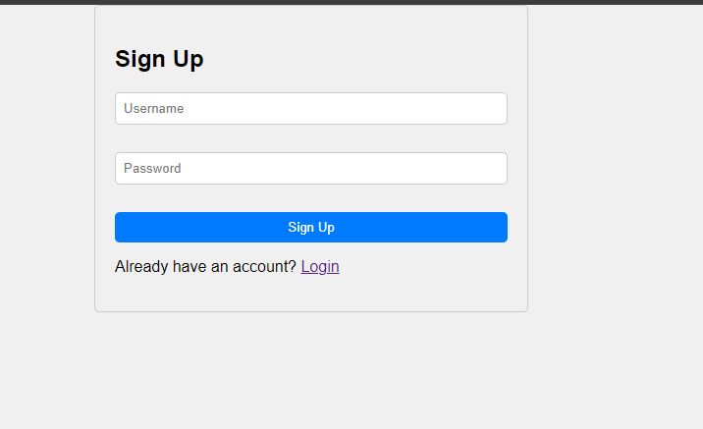

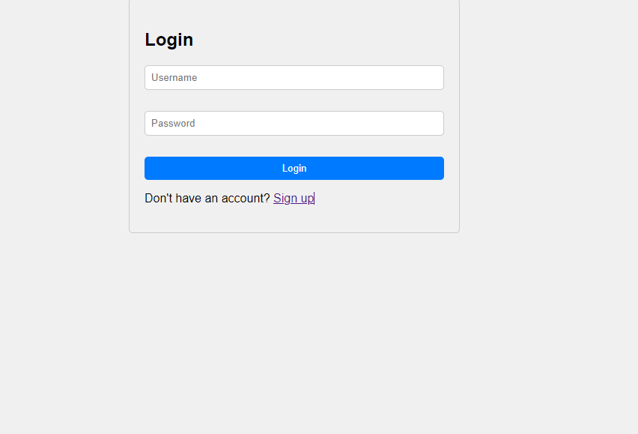

Step 2: Dashboard

After successfully logging in, users are greeted with the application dashboard, which provides an overview of the book that users added. From the dashboard, users can navigate to different sections of the application, including creating new book, viewing existing book, and managing account settings.



Step 3: Creating a “New Book”

To create a new task, users can click on the "Create new Book" button or navigate to the book creation page from the dashboard. Here, users can enter a title and description for the book, set price, description and images, and can create the book.

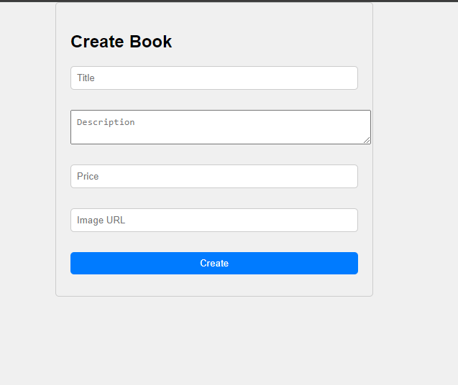

Step 4: Editing and Updating Book

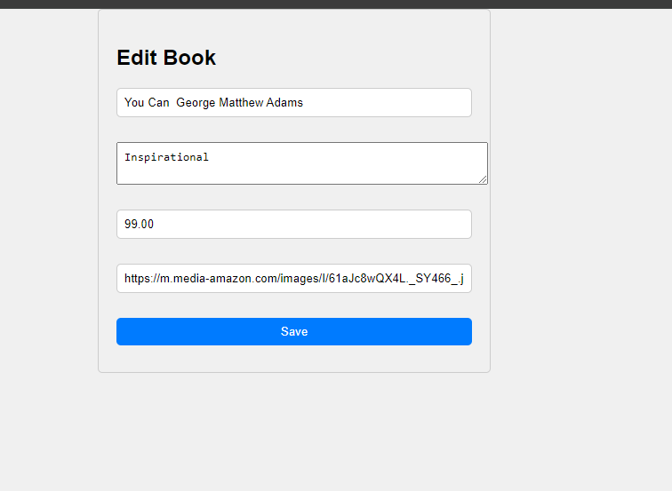

Users have the ability to edit and update existing book as needed. From the Edit Book, users can click on individual Book to access the Book details page, where they can make changes altogether.

Step 5: Logging Out

To ensure the security of their account, users can log out of the application by clicking on the "Logout" button, which is typically located in the account settings or navigation menu. Logging out terminates the current session and redirects users to the login page.

5.Learning Outcome

The development of our cloud-based to-do list application has been a rich learning experience, enhancing our understanding of cloud computing, backend development, frontend design, agile project management, deployment automation, and problem- solving. Through hands-on work with AWS services like Elastic Beanstalk, RDS, EC2, and S3, we've learned to leverage cloud infrastructure for scalability, reliability, and security. Our proficiency in PHP backend development, HTML/CSS/JavaScript frontend design, and agile project management methodologies has been sharpened, enabling us to create intuitive interfaces, manage project iterations efficiently, and deploy applications seamlessly. Furthermore, troubleshooting challenges along the way has honed our problem-solving skills, fostering resilience and adaptability in the face of complex technical issues. In conclusion, this project has equipped us with a diverse skill set and a deeper understanding of software development principles, preparing us for future endeavors in the field.In conclusion, the learning outcomes from this project extend far beyond technical expertise, encompassing essential skills in cloud computing, backend and frontend development, agile project management, deployment automation, and problem-solving. Armed with this diverse skill set and deeper understanding of software development principles, we stand ready to tackle future challenges and make meaningful contributions in the dynamic landscape of software engineering.

